Ideation Phase
Brainstorm & Idea Prioritization Template

Date | 19 September 2026
Student ID | 23NU1A4429
Project Name | Automated Network Request Management in ServiceNow
Maximum Marks | 4 Marks

Step-1: Team Gathering, Collaboration and Select the Problem Statement
Our team initiated the project through collaborative discussions to identify a practical enterprise IT problem that could be addressed using the ServiceNow platform. The team examined the complete lifecycle of network-related service requests, beginning with user submission and continuing through information collection, request processing, approval, assignment, fulfillment, tracking, and closure.
Rather than immediately selecting a technical solution, the team first analyzed the process from multiple stakeholder perspectives, including the requester, service desk, network/IT support team, and management. This collaborative approach helped the team identify where manual intervention, repeated data entry, disconnected records, and limited process visibility could affect the efficiency and reliability of network request handling.
The team specifically explored the following stages:
- Network request submission through the Service Portal
- Collection of requester and network-service information
- Generation and tracking of REQ/RITM records
- Processing and approval of requests
- Creation of corresponding operational records
- Assignment of fulfillment work
- Network Database record management
- Network Task creation and processing
- Status tracking throughout the request lifecycle
- Requester communication and notifications
- Request completion and closure
Through these discussions, the team established that the project should address the complete request lifecycle rather than focusing on a single isolated activity.

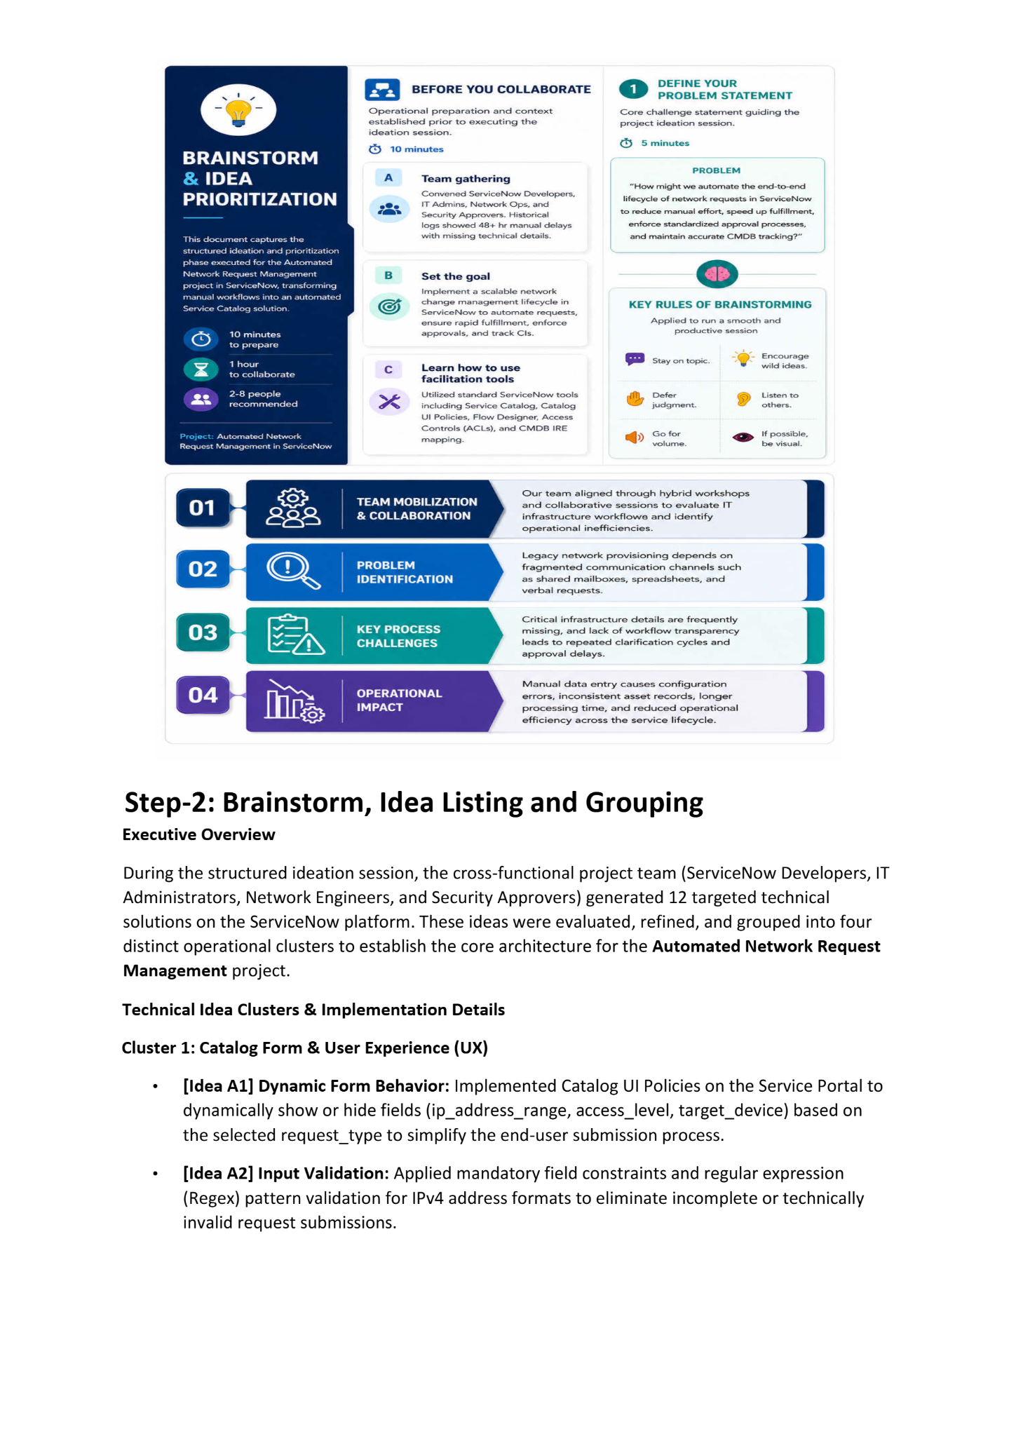
Step-2: Brainstorm, Idea Listing and Grouping
During the structured ideation session for the Automated Network Request Management using ServiceNow project, the project team generated and evaluated multiple technical ideas focused on simplifying network request submission, automating downstream record creation, maintaining consistent information across records, streamlining approvals and task fulfillment, and improving requester communication. The ideas were refined and grouped into four operational clusters that formed the core functional direction of the proposed solution.

Technical Idea Clusters & Implementation Details

Cluster 1: Service Catalog & Requester Experience
- [Idea A1] Standardized Network Request Catalog: Created a dedicated Network Request Catalog Item in ServiceNow Service Catalog to provide users with a structured and standardized method of submitting network-related requests through the Service Portal.
- [Idea A2] Requester Information Auto-Population: Configured Catalog Variables and variable-set relationships so that requester information such as Opened on behalf of, User Name, Email ID, and Phone Number can be automatically populated from the selected user record, reducing repeated manual data entry.
- [Idea A3] Controlled Request Information: Designed the catalog form to collect the required network-request information while using appropriate mandatory, read-only, and auto-populated fields to improve data consistency and prevent unnecessary modification of system-derived information.

Cluster 2: Automated Record Creation & Data Mapping
- [Idea B1] Automated Request Processing: Designed a Flow Designer process triggered by the submission of the Network Request catalog item, allowing the submitted catalog information to initiate the downstream automation automatically.
- [Idea B2] Automated Network Database Creation: Configured the flow to automatically create a corresponding record in the Network Database table after the Service Portal request is submitted, eliminating the need for manual database-record creation.
- [Idea B3] Automatic Field Mapping Across Records: Designed data mapping from the submitted catalog variables into corresponding Network Database and Network Task fields, including requester and network-request details, so that information does not need to be manually re-entered.

Cluster 3: Approval, Task Orchestration & Fulfillment
- [Idea C1] Automated Network Task Generation: Configured Flow Designer to automatically create a corresponding record in the Network Task table from the submitted network request, establishing a structured fulfillment record.
- [Idea C2] Approval-Based Processing: Integrated an approval stage into the automated lifecycle so that the Network Task can proceed according to the configured Approval Status rather than relying entirely on manual coordination.
- [Idea C3] Automated Task Assignment & Status Handling: Configured the Network Task process to maintain Assigned to and Work Status information, allowing the fulfillment team to receive and process the generated task through defined lifecycle states.

Cluster 4: Tracking, Synchronization & Requester Communication
- [Idea D1] Request-to-Task Traceability: Maintained the relationship between the original REQ/RITM, Network Database record, and Network Task, allowing fulfillment teams to trace the operational record back to the submitted request.
- [Idea D2] Controlled Task Record Updates: Configured system-generated fields such as Task Number, Database Number, and Request Number to be automatically populated and protected as read-only where appropriate, preventing accidental manual changes to system-generated identifiers.
- [Idea D3] Automated Completion Notification: Designed an automated notification mechanism to send an email to the Requested For user when the Network Task reaches the configured completion/resolution status, providing confirmation without requiring manual follow-up.
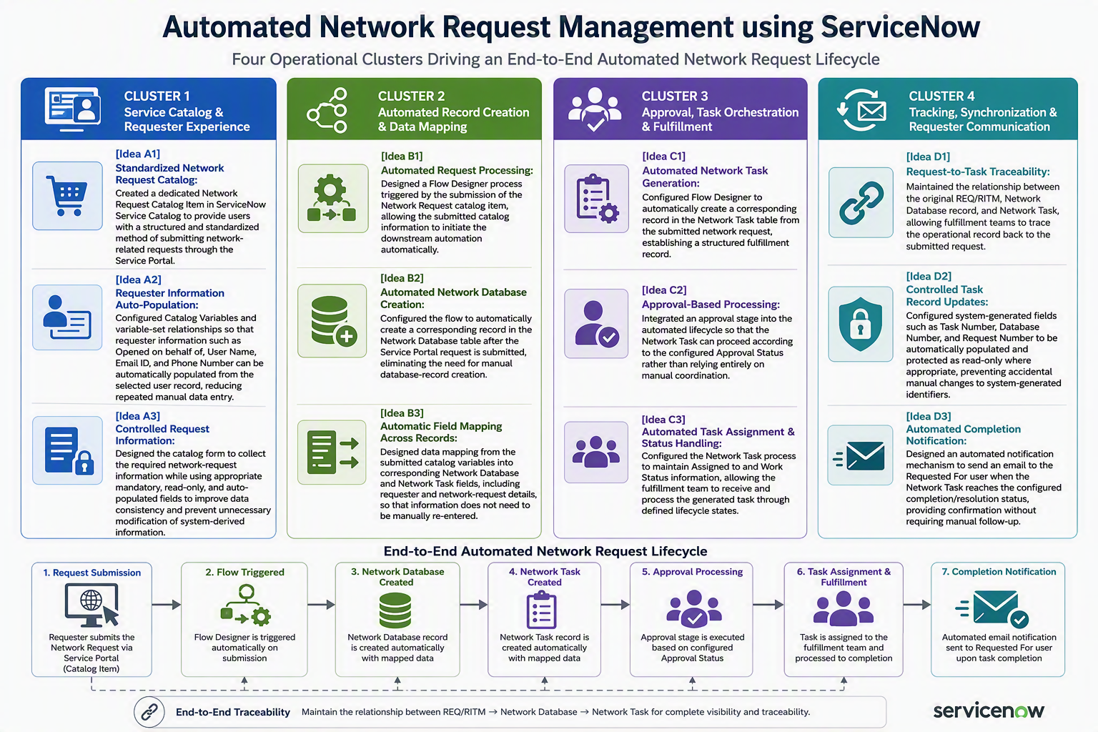
Step-3: Idea Prioritization
Based on this prioritization, the final solution automates the complete network request process from request submission and approval to task assignment, execution, notifications, and ticket closure. This approach is expected to significantly reduce manual effort, improve SLA compliance, enhance transparency, increase operational efficiency, and deliver a faster and more reliable experience for both end users and network administrators
